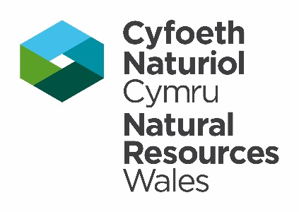

## Reference Template Form

## This form should be completed by referees to support applications made for survey, conservation/project specific, and European Protected Species (EPS) development licences.

The referees should demonstrate their own experience working with the species in question, and provide comments in respect to their knowledge of the applicant’s experience relating to the species. Further guidance on providing references is provided in the corresponding application forms.

1. **Referee Contact Details**

|  |  |  |  |  |
| --- | --- | --- | --- | --- |
|  | Title (Mr/Mrs/Miss/Ms) | Forename(s) | | Surname |
|  |  | |  |
| Business Title (if appropriate) | |  | |
| Company Name (if appropriate) | |  | |
| Address | |  | |
|  | |
| Town | |  | |
| County | |  | |
| Postcode | |  | |
| Tel. number (incl. national dialling code) | |  | |
| Mobile. number (incl. national dialling code) | |  | |
| Email address | |  | |

### Referee Experience

|  |  |  |  |  |
| --- | --- | --- | --- | --- |
|  | Please provide the reference numbers for any relevant licences issued by the following within the last two years: | | | |
| Natural Resources Wales |  |  | |
| Natural England |  |  | |
| Scottish Natural Heritage |  |  | |
| Other: |  |  | |
| Please confirm how long you have held this licence (please note that to provide a reference, you must have held a relevant licence for **at least** **two years**): | | |  |
| Please provide a summary of **your** experience and skills relating to the species and activities listed in Section 2 | | | |
|  | | | |

1. **Licence Application Details**

|  |  |  |  |
| --- | --- | --- | --- |
|  | Nature of licence applied for: | | |
| Survey licence | |  |
| Conservation/project specific licence | |  |
| EPS development licence | |  |
| Other: | |  |
| **Species to be affected (e.g. Bats, Dormouse, GCN)** | **Licensable activities and methods** | |
|  |  | |
|  |  | |
|  |  | |
|  |  | |
|  |  | |

### Referee’s Knowledge of the Applicant’s Skills and Experience

|  |  |  |
| --- | --- | --- |
|  | Applicant Name: |  |
| Please confirm how long have you known the applicant: |  |
| Please state how you know the applicant (e.g. professional consultancy, conservation group). If you **currently work professionally** with the applicant please make this clear. |  |
| Have you read the applicants application form for the licence application? | Yes  No |
| To your knowledge, does the information provided within the application form reflect accurately the skills, knowledge and experience of the applicant? | Yes  No |
| This reference will provide confirmation the applicant has demonstrated the competencies necessary to undertake the licenced activities unsupervised, to a professional standard and in such a way that will benefit the favourable conservation status of the species.  Please provide a detailed summary of the applicant’s knowledge, skills and practical experience which you believe provides them with the necessary abilities to undertake professional ecological work for this species. Please explain and **give examples** where you have supervised, trained or worked with the applicant and they have shown the necessary competencies which you can attest is more than satisfactory to permit them a licence for the activities and methods which they have applied for. | |
|  | |

### Declaration

|  |  |  |  |  |  |
| --- | --- | --- | --- | --- | --- |
|  | Signature of the **Referee** | |  | **Date** |  |
| ***For references submitted electronically, please tick this box to confirm the details you have provided are a true and accurate record*** | | | | |  |
|  | | Name in BLOCK LETTERS |  | | |

Please return this form to the below address

|  |
| --- |
| **By Post**  Species Permitting Team,  Natural Resources Wales,  Maes y Ffynnon,  Penrhosgarnedd,  Bangor,  LL57 2DW  **Electronically**  [specieslicence@naturalresourceswales.gov.uk](mailto:specieslicence@naturalresourceswales.gov.uk)  **Telephone:** 03000654974 |
|
|
|
|
|