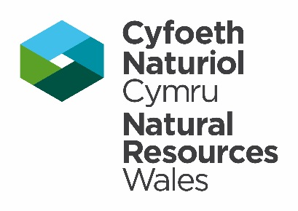



Template Method Statement to be used within European Protected Species Development Licence Application (Cetacean, Marine Turtle or Common Sturgeon)

This template Method Statement is to be used to form part of your Licence Application for a European Protected Species Development Licence. It will be used to determine the impact of the application on the favourable conservation status of the species concerned (Regulation 55(9) (b) of the Conservation of Habitats and Species Regulations 2017) or Regulation 55(7)(b) of the Conservation of Offshore Marine Habitats and Species Regulations 2017. It must be prepared by a consultant ecologist of other suitably qualified person. Please submit your Application and supporting Method Statement electronically to the contact details provided below.

Contact Details

Natural Resources Wales

Species Permitting Team

Maes Y Ffynnon

Penrhosgarnedd

Bangor

LL57 2DW

03000 654974 / 03000 654921

[specieslicence@naturalresourceswales.gov.uk](mailto:specieslicence@naturalresourceswales.gov.uk)

[trwyddedrhywogaeth@cyfoethnaturiolcymru.gov.uk](mailto:trwyddedrhywogaeth@cyfoethnaturiolcymru.gov.uk)

|  |  |
| --- | --- |
| Method Statement Title: |  |
| Method Statement Version Number: |  |
| Method Statement Issue Date: |  |
| Site / Area of development proposed: |  |

Background and Supporting Information

**A Executive Summary.**

No more than one side of A4

**B** **Introduction**

**B.1** **Background to activity/development**

Include a brief summary of what the proposed activity is and why it is necessary.

**B.2** **Full details of proposed works on site that are to be covered by the licence**

Please ensure sufficent detail is provided on the proposed works e.g. construction, survey etc. Include current status of any consents (if applicable) and any outstanding conditions/reserved matters. Include timescales and order of work.

**B.3 Actions requiring licensing**

E.g. disturb, capture, translocate or kill. Briefly explain why these actions are necessary.

**C** **Impact assessment** – potential impact of proposed works in absence of mitigation/compensation (e.g. disturbance, killing, injury). Provide a summary of the conclusions from your Environmental Impact Assessment or Habitats Regulations Assessment (where applicable).

## Delivery Information - Mitigation, compensation and monitoring

Description of how the impacts will be addressed in order to ensure no detriment to the maintenance of the population at a favourable conservation status.

**D Works to be undertaken**

Please identify which works will be undertaken or supervised by an ecologist

**E Timetable of works**

Include timings of all development activities and mitigation measures, monitoring and other post development works

**F References**

Credits for source information.

|  |  |  |  |
| --- | --- | --- | --- |
| I declare that should a licence be granted, the work as proposed in this Method Statement will be strictly adhered to. I understand that any deviation from the works as proposed in this Method Statement without agreement from NRW would result in a breach of the licence.  ***NB****. Applicants should note that it is an offence under regulation 59 of the Conservation of Habitats and Species Regulations 2017 or Regulation 57 of the Conservation of Offshore Marine Habitats and Species Regulations 2017 to knowingly or recklessly provide false information in order to obtain a licence*. | | | |
| Signature of the **Applicant** |  | **Date** |  |
| ***For electronic submissions please insert an electronic signature above or place an x in the box opposite to confirm agreement with the declarations above.*** | | | ☐ |
| Full name in BLOCK LETTERS |  | | |
|  | | |  |
| Signature of the **Ecologist** |  | **Date** |  |
| ***For electronic submissions please insert an electronic signature above or place an x in the box opposite to confirm agreement with the declarations above.*** | | | ☐ |
| Full name in BLOCK LETTERS |  | | |

**G Declaration**

**H Annexes**

**H.1** Pre-existing survey reports

**H.2** Raw survey data.