Mae Cyfoeth Naturiol Cymru yn datblygu rhestr o anghenion tystiolaeth sy'n gysylltiedig â'r amgylchedd dŵr yng Nghymru. Mae'r ddogfen hon yn amlinellu ein syniadau cynnar ar themâu a phrosiectau ymchwil sy'n gyfleoedd i weithio ar y cyd. Mae gennym ddiddordeb yn eich barn a’ch syniadau i ddatblygu'r rhestr hon ymhellach a chyflwyno cynnydd. Anfonwch eich sylwadau i:
WFDWales@cyfoethnaturiolcymru.gov.uk

Natural Resources Wales is developing a list of evidence needs relating to the water environment in Wales. This document outlines our early thinking on research themes and projects which are opportunities for collaborative working. We are interested in your views to develop this list further and progress delivery. Please submit comments to: WFDWales@cyfoethnaturiolcymru.gov.uk

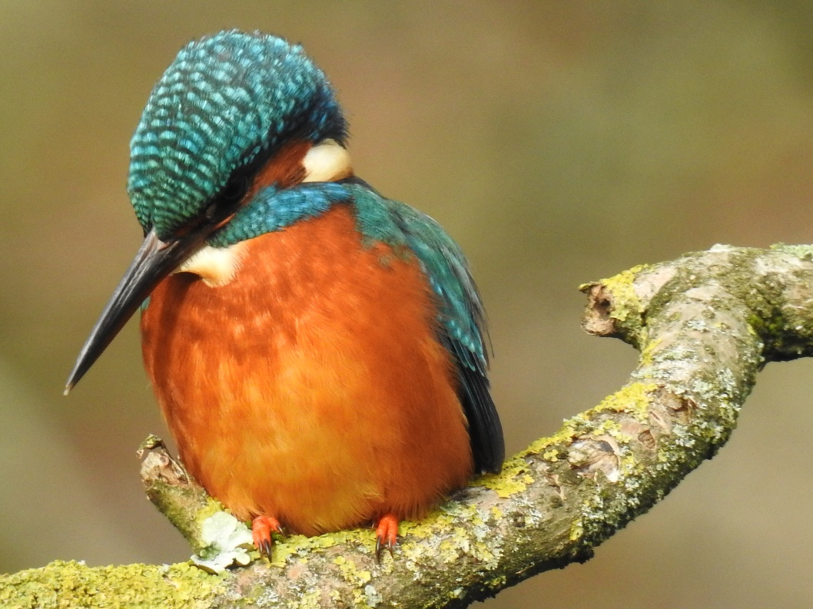
Photo by Tracey Dunford

Introduction

The purpose of this document is to share our early thinking on research priorities for the water environment, and to facilitate discussion with partners on collaborative delivery of evidence.

Natural Resources Wales’ purpose is to pursue the sustainable management of natural resources in relation to Wales and apply the principles of sustainable management of natural resources in the exercise of our functions. This means working collaboratively to protect and enhance our air, land, water, biodiversity and ecosystems to improve Wales’ well-being, and provide a better future for everyone. NRW is an evidence-based organisation. We seek to ensure that our strategy, decisions, operations and advice to Government and others is underpinned by sound and quality-assured evidence. We recognise that it is critically important to have a good understanding of our changing environment, something that we highlight in our State of Natural Resources Report (SoNaRR) for Wales. Whilst we have limited funds available for research, we recognise that there are many opportunities to work with others to gather the evidence fundamental to delivering the sustainable management of natural resources and supporting place-based solutions to environmental challenges.

The draft research priorities in this document were identified through consultation with NRW staff. Discussion has begun with the academic community in Wales, and we will use Environment Platform Wales to engage further in 2019. This exercise will inform the updated SoNaRR due for publication in 2020.
We welcome all enquiries and discussion with partners interested in working collaboratively to deliver research needs. In particular, we want to know of existing and planned research that could meet our needs, or if you have views on priorities or gaps in knowledge we have not identified. Please submit comments to: WFDWales@cyfoethnaturiolcymru.gov.uk

Scope & themes
This document does not cover all NRW’s evidence needs within the water environment. A separate publication is available on our website for marine biodiversity collaborative research priorities. Further information on flood risk evidence needs is available on request.

In scope • freshwater and ground water quality and quantity • estuarine, coastal and marine waters • water resources • flows • Water Framework Directive (WFD) • freshwater ecosystems and biodiversity • physical processes that impact on freshwater ecosystems • fluvial geomorphology • hydromorphology • monitoring & surveillance of the water environment • catchment management • water users

Out of scope • flood risk management • marine biodiversity • marine renewable energy • terrestrial habitat • coastal geomorphology

The evidence needs are presented in the following themes, which overlap:
• Water quality • Monitoring
• Water resources • Land management
• Ecosystems

Water Quality

Development of an improved ability to report source apportionment for diffuse pollution in catchments. We welcome collaboration to enable a clearer picture of contributions from across all sectors, including agriculture, water industry, septic tanks.

How to assess cumulative effects of sewage discharges when issuing permits for new discharges. There is a need for tools to better assess the loading from existing discharges within a catchment when assessing applications for new discharges. Current NRW guidance is geared towards assessing each sewage discharge permit application to ground on its own merits, but new tools would help assess if the catchment can accommodate additional loading.

Understanding groundwater pollution risks from spreading organic material to land such as slurry, digestate, sewage sludge and organic wastes. Recent evidence in Wales has shown a causal link between groundwater pollution and spreading, with some instances resulting in a chemical imbalance. It is possible that other groundwaters in Wales are at risk. We require an improved evidence base to investigate this and aid the development of policies to control activity for at risk locations and conditions. Options may include monitoring groundwater where spreading occurs to see if particular ground conditions are unsuitable.

Can we develop better source apportionment of metals from abandoned mines? Expensive remediation schemes may fail to deliver expected benefits unless there is an improved understanding of source apportionment and flow impacts. Better methods are required, e.g. use of continuous tracers to capture hyporheic flow.

Investigating the impact of phosphorus from domestic package treatment plants (PTPs) on river water quality. Domestic sewage accounts for a significant proportion of phosphorus (P) generated and discharged to our rivers. Studies suggest PTPs permitted to discharge to water do not treat P to EQS/WFD standards. Appropriate assessment of P concentration/loadings from PTP's both locally and at the catchment scale is needed to determine the impact on WFD and river water quality. The evidence could be used to support the local and national permitting and planning process.

Is there a technological solution to upgrade existing domestic package treatment plants (PTPs) to deliver improved phosphate removal? Domestic sewage accounts for a significant proportion of phosphorus (P) generated and discharged to our rivers. Studies suggest PTPs permitted to discharge to water do not treat P to EQS/WFD standards. There may be affordable engineering solutions to retro fit improved phosphate removal functions. Testing of aluminium or iron chemical dosing techniques has shown P removal at the test bench level, but requires careful pH control due to alkalinity loses by addition of acidic chemicals. Is there a way to achieve this reliably with low risk of acid contamination by householders?

Improving our strategic understanding of the impact of septic tanks on the water environment in Wales. Compared with the UK average Wales has a proportionately higher dependence on private septic tanks. We require a better understanding of what proportion are being mismanaged. We also require clarity on the density at which these become a significant risk to a catchment, and where the hotspots are in Wales. This project could build on previous work at Llyn Padarn in Snowdonia national park and may include identifying other target areas for awareness raising at the community level.

Understanding groundwater pollution risks from sewage and trade effluent discharges to ground. Current discharges may be contributing to diffuse pollution across Wales despite meeting the current best practice and standards. Are the standards we use when assessing these discharges still appropriate? An option is to monitor groundwater around existing large sewage discharges to investigate if there are particular ground conditions which are unsuitable across Wales. We may lead to the development of policies to control activity and reduce pollution risks.

How best to develop bathing and shellfish water quality prediction systems? NRW has a rich data source that could be used to produce a new prediction system for bathing and shellfish water quality in Wales. We welcome collaboration to work with us in developing such tools to add value to our existing monitoring programme for bathing and shellfish waters in Wales.

How do shellfish waters (SFWs) respond to river flushing events? We know that bathing waters are impacted by river flushing (high bacterial loads washed downstream), but how does this impact on SFWs? Can we improve the understanding of the relationship between water quality and shellfish flesh quality? What is the economic and social benefit of improving Shellfish quality? This information would be of use in generating prediction models for SFWs.
Bacterial decay and mortality in marine and intertidal areas. How quickly do the main bathing water compliance bacteria (E. coli and Intestinal enterococci) decay under different marine conditions, e.g. sediment regimes, different salinities and temperatures. Decay values come into play in numerical models of the marine environment, and we want to understand what the bacterial loading is at various locations.

Develop a better understanding of the relationship between nutrient inputs, algae growth and undesirable balance in the context of eutrophication and the Water Framework Directive. This is particularly pertinent to estuarine and coastal waters where the relationship between nutrients and algae growth is complex and dynamic due to multiple pressures acting on these waters. Also, a better understanding of phytoplankton dynamics and WFD status in macrotidal estuarine and coastal water bodies is required.

There is a need to develop our understanding of the sources and potential impacts of emerging chemicals on ecology and human health, such as antimicrobial resistance. We also need to better understand how mixtures of chemicals impact on ecology and in combination with other environmental pressures, and the risk to the water environment and human health.

Improved understanding of the local and/or chronic impacts of non-compliance (i.e. with discharge limits) events on the water environment and ecosystem resilience. Modelling to assess applications for new discharges is sound, but being able to establish the consequences of, for example, a sewage treatment works exceeding its permitted limits (e.g. flow, Ammonia, BOD) would serve to significantly improve our management of water quality and inform any additional loading decisions.

Water Resources

Understanding the potential impacts of drought on our ecosystems, natural resources and people’s wellbeing across Wales. We welcome collaboration to further build upon current research to develop an understanding of the extent and severity of drought impacts across Wales. This will inform the way we plan for and manage our response to droughts, including implementing measures to reduce these impacts and building resilience where our ecosystems, natural resources and people’s well-being are most at risk.

Understanding future multi-sector water use needs, including peak demands and identify how we can improve water security in the face of pressures such as climate change. Climate change, population growth and environmental drivers are putting pressures on our water resources. This could impact our ability to ensure a secure supply to people, business and industry. Building upon current research in this field, we need to understand how water demand may change (particularly outside of the water industry), when and where this presents risks and how it can be managed such as increasing water efficiency.

How can we better understand climate change impacts across Wales? We know from current research that average natural summer flows in rivers could drastically reduce by between 50 and 80 % across Wales. However, the potential impacts and the consequences of these changes on our ecosystems, natural resources and people’s wellbeing remains poorly understood.
Some specific research questions to consider include:
• Which habitats and species associated with the water environment are most vulnerable to climate change and where are they in Wales?
• How much change should we expect in river flows, sea level rises, water temperature, nutrient concentrations, dissolved oxygen and the populations of aquatic plants and animals?
• How might the availability of water for users such as environment, agriculture, forestry and people change?
• How does land-use change affect water availability and environmental quality?

Understanding the effects of climate change on groundwater resources in marginal aquifers across Wales. The recent hot and prolonged dry weather in 2018 highlighted that groundwater fed private water supplies (supplying around 5% of the Welsh population) are vulnerable to a changing climate. There is a need to better understand the effects of climate change on groundwater resources in marginal aquifers and private water supplies across Wales.
Specific research questions include:
• How does groundwater respond to extended droughts? Can we identify and understand non-linearities in groundwater response? Does groundwater recharge change?
• How resilient is groundwater to climate impacts and where are the vulnerable areas? Where are the private water supply hotspots in Wales?
• What are the solutions for ensuring resilience of these supplies? What is the potential for using aquifer storage and recovery?

Understanding the water abstraction needs within Wales of existing and potential licence holders. We need to further our understanding of water needs (including seasonality) of current and potential abstractors across the different sectors in Wales, e.g. agriculture and industry. This will include updating the 'Optimum use of water for industry and agriculture dependent on direct abstraction - best practice manual' (2002) with current Welsh specific datasets from each sector.

Development of novel techniques for low flow monitoring. We are seeking more cost effective and innovative techniques, including modelling on existing (or donor) sites that may offer better resolution and more robust low flow monitoring. In addition, identify how this could guide the design of further monitoring networks.

Estimation of open water evaporation. Current methods of estimating open water evaporation vary and there is no adopted best method within Wales. Therefore, the objectives would be
• evaluate current methods of estimating open water evaporation;
• recommend the best available practicable methodologies for producing robust estimates;
• assess the associated uncertainty of these methodologies

Ecosystems

Improving the evidence of biodiversity and fisheries benefits from key river restoration techniques. In conjunction with the International Union for Conservation of Nature (IUCN) this could include analysis in locations where a number of interventions have been carried out, or a review of available evidence. A number of sites in Wales could be selected, e.g. the River Olway which has had 10 years of successive projects for habitat improvements and river restoration.

We require an improved understanding of the impact of pollution incidents on the ecology of catchments. In Wales each year there are hundreds of minor incidents such as spills from combined sewer overflows (CSOs) or poor slurry spreading practices. Some catchments suffer repeat incidents. How well do we understand the impacts on ecology of more frequent low-level pollution? Evidence could inform CSO improvements and targeting of land management measures.

Quantifying the effect of small scale, high-head, run-of-river hydropower schemes in Wales on in-river ecology and geomorphological processes. There is a need for monitoring and analysis of individual hydropower schemes to investigate the effect of varying abstraction rates on invertebrates, fish and bryophytes within the depleted reach, and to determine how siting and design of intake weirs affects sediment transport. Increased understanding of impacts will help us to better assess the environmental risks associated with individual small scale schemes and inform future licensing and water management decisions.

What are the cumulative impacts of small scale hydropower schemes in Wales? There is little empirical evidence relating to the cumulative impact of multiple small scale hydropower schemes within a catchment. There is a need to carry out catchment scale monitoring and analysis of the cumulative impact of intake weirs and abstractions on fish, invertebrate and bryophyte populations, plus effects on sediment transport and in-river habitat quality.

What are the long-term impacts of hydropower schemes on bryophytes? NRW has some baseline monitoring plots for riverine bryophytes that require increased monitoring effort to get robust statistics.

Biological indexing tools to help prioritise metal mine remediation and assess benefits post remediation. There is a need to improve understanding of ecological impacts of metal mines in Wales and the potential recovery of aquatic ecosystems following remediation schemes. Development of existing tools is required for practical use in Wales.

Can we improve understanding of the impacts from WFD monitored chemicals on intertidal Natura 2000 features? This would improve confidence levels for chemical and metals thresholds for habitat directive reporting and help determine if some WFD element failures also have an impact on intertidal Natura 2000 feature condition.

Understanding freshwater abstraction impacts on estuarine Natura 2000 features as a result of flow moderation. Licensed abstraction activity in coastal areas can result in cessation of flow in small coastal water bodies, leading to a net reduction in fresh water input to Welsh estuaries. The cumulative impact on intertidal features is not understood but may have implications for conservation status.

Understanding the thermal standards for fish in the marine environment. For the marine environment we currently use temperature targets set for fish in freshwater, which is a method agreed by a UK technical advisory group for all agencies. There is limited understanding of how applicable these standards are to the marine environment. We welcome the design of a set of appropriate and robust temperature targets based on marine evidence for both fish and molluscs to guide marine developments.

Linking flows to ravine humidity. Recent research shows that flows can affect relative humidity in ravine ecosystems. The scale and dynamism of this linkage remains un-investigated. To better inform abstraction permits, there is a need for analysis of multiple variables using a network of microclimate monitors.

Monitoring

How best to collate evidence on the physical form and processes of Wales’ rivers and riparian zones? NRW don’t currently monitor for geomorphology across Wales. This project would help inform how we meet current and future monitoring needs, aiming to support regulatory decisions and the development of a river restoration programme.

Develop a sampling protocol for use of redox surveys to determine habitat suitability for freshwater pearl mussel. NRW trials of redox surveys have identified difficulties with “repeatability”. This project would inform operational practice.

Analysis of long term water quality trends in acidified waters to inform future measures. There are a number of active liming projects in Wales. Assessment is required to ensure sustainable recovery of acidified waters.

Development of novel and low cost techniques for monitoring water quality, biology and flows. Monitoring is a critical part of NRW’s statutory role and is also important to local delivery. Research could support NRW’s delivery of statutory requirements or facilitate improved local monitoring by communities and partnership projects.

Techniques to monitor temporal trends in sediment contaminants in rivers. This is required for the Water Framework Directive to identify if measures for some chemicals have been effective but trials by NRW have been confounded by difficulties.

Develop exposure- and effect-directed tools to evaluate risks resulting from discharge of chemicals to surface and ground water. To improve understanding of risks posed by potentially toxic chemicals not currently part of NRW’s statutory programme, and in combination effects.

Investigate the sources and impacts of litter on the water environment and its uses. Identify effective controls to reduce the sources of litter.

Evidence of impacts from septic tanks and surface water discharges in the Gwent Levels SSSI system. Targeted monitoring to better understand the impacts of discharges on the condition of small water courses.

Land management

Understanding the benefits of Sustainable Drainage Systems (SuDS). Including:
- evidence of effectiveness to reduce pollution from rural land management and infrastructure.
- monitoring and assessing the benefits of schemes implemented for new development in Wales.
- assessing the relative effectiveness of different scheme designs in terms of pollution risk, infiltration, groundwater recharge.
- understanding the wider benefits to biodiversity and communities.

The effectiveness of constructed wetlands to treat lightly fouled water from farm yards, including design standards and effective removal rates for pollutants. We need to develop practical and cost-effective approaches to reduce pollution from agricultural activities. Constructed wetlands are a potential solution to managing lightly fouled water.

What are the wider benefits of wetland restoration and water retention measures on upland and agricultural land to river flows, water levels, livestock, biodiversity and habitat? Improving our understanding of the delivery of multiple benefits.

Understanding the risk of failure in slurry management systems. Research required to assess factors contributing to failures in slurry management systems and consequent pollution incidents, including age, maintenance and condition, design and capacity, construction materials.

Develop a strategic understanding of the impacts of increased agricultural production on nutrient loadings in catchments and the risks for the water environment. Including, assessing available land bank for agriculture and nutrient recovery, identifying sensitive areas, and exploring potential trends in production and environmental risks.

