June 2022

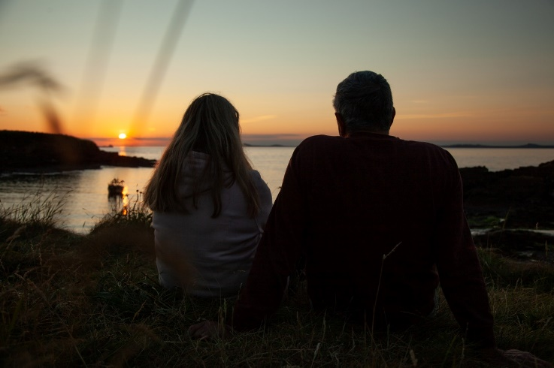
“Here comes the sun” – customs celebrating the onset of summer from around the world
Most people are aware of how Christmas is celebrated around the world, but have you ever asked your learners to pause for thought and investigate how the arrival of summer is celebrated? From warmer weather to Wimbledon whites, family picnics, indulging in a drop of Pimms to the great scone debate as to whether the cream or jam goes first (we suggest jam first!), why not set your learners the task of investigating the different ways summer is celebrated and observed around the world?

The upcoming Summer Solstice symbolises ‘the longest day of the year’ in the Northern Hemisphere, the day when the sun is leaning furthest North in the sky. Bringing with it longer hours of daylight, this year it takes place on Tuesday the 21st of June. You may have seen the celebrations that take place at Stonehenge as people flock to view the sunrise hitting the stones but have you heard of Bryn Celli Ddu? It is one of Anglesey’s most famous prehistoric landmarks and as the sun rises on the summer solstice, shafts of light shine directly down the tomb’s passageway to illuminate the chamber within. A sight to behold!

How do other countries in the Northern Hemisphere celebrate the kick-off of Summer? Why not try incorporating some global culture into your sunny days this month.

Barefoot walking
Of all the traditions, Sweden’s Midsommar is considered by many to be the pinnacle of solstice celebrations. Much like other northern and Scandinavian countries, welcoming in the warmth and sun brings festivities across the country. Copy the Swedes and take your learners on a morning’s barefoot walk in the grgass of your setting’s grounds whilst it’s fresh and dewy. The dewdrops are thought to be beneficial for health. Embrace the feeling of nature on bare feet, Activity 1 in our Health and Well-being booklet.

Flower Crowns
Both Latvia and Sweden are known for their floral and leafy headwear during Solstice celebrations. Flower crowns have long been a symbol of rebirth and fertility, so the wearing of them is connected to the essence of summer, with both men and women wearing them. Ask your learners to create their own midsommarkran with leaves, Activity 5 in our Getting Creative Outdoors booklet or with flowers here. Everyone will surely enjoy making beautiful crowns to wear while eating strawberries or trying some Swedish pickled herring!

Making a fire
Cold-climate countries, such as Norway, Finland and Iceland, celebrate the several extra hours of light by building bonfires. Since the Viking age, bonfires are believed to boost the sun’s strength, ensuring a healthy harvest and to ward off evil spirits. Latvians are even known to leap over the bonfires that are kept burning all night long! If you are a Level 3 Forest School Leader or have suitable experience and plan on lighting a fire with your learners, remember to stay safe, keep everyone at a safe distance and ensure you have the correct equipment. Guidance on campfire cooking is available here.

Looking for learning resources, information or data? Please contact:
education@naturalresourceswales.gov.uk or go to https://naturalresources.wales/learning
Alternative format; large print or another language, please contact:
enquiries@naturalresourceswales.gov.uk
0300 065 3000

