FEB-01 – Bird Observation Log for Riverine and Large Stillwaters
This observation log should be used for counting fish-eating birds (Cormorant, Goosander and Heron) on rivers and large stillwaters (ie large waterbodies). Fish-eating birds are highly mobile and their activity changes at different times of the day and different seasons of the year. This means that it is important to collect data in the time of year for which you are applying for a licence (i.e. winter) and that you record variability in numbers and behaviour through that season in order to fully understand the distribution of birds over time and where the greatest the impact may be occurring at a particular site. Variability is best recorded by making several visits to the same site – using the same recorder and the same reporting method but on different days and (ideally) at different times of day. This log sets out a reliable counting and reporting method used in standard surveys, and provides tables to make repeat counts easy to record and report to NRW.
COUNTING AND RECORDING METHOD
1. Decide on the site/reach to be counted: linear sites (e.g. sections of rivers) each ‘site’ no more than 2km long but a longer stretch may be counted as a series of several 2km ‘sites’ and one copy of the log filled in for each site. Still-water sites: try to break up a large lake into comparable sections ie grid-based approach. Counts should take place within count sectors prior to any scaring activities. Counts must be undertaken during those months when you wish to shoot birds, and at the time of year that damage occurs. The number of birds counted is the maximum number of birds that were counted on a single visit for a single count sector that day. Do not give the cumulative number of birds seen as a result of several counts in one day.
2. Sketch or print a map of the count sector site: Record the 6 figure National Grid References (NGR) of the start and end point of each count site. In addition, sketching or noting useful landmarks will help you to remember the site boundaries and will help make your repeat counts more reliable. You must include a map which clearly identifies each count sector.
3. Record date, start and end time: for each count sector of each ‘site’ (
4. Birds arriving and leaving: count birds that arrive into or leave the site during your count UNLESS you are walking a stretch of linear water (river reach) and they fly over your head and go in ahead of you – in this case you will see these birds again later in the survey and they should not be double-counted.
5. Count individuals by activity: wherever possible, count the birds according to what they are apparently doing. There are boxes in the count table for each of the likely activities. If the birds are doing something else or you do not have time to record activity there is a ‘no behaviour’ column.

TIPS FOR REPORTING TO NRW
1. Make more than one count per site
The more times you repeat a count, the more reliable your reported data is likely to be. Especially count at different times of day and through the season, and aim to provide data from at least one count sector per month, for each site / reach.
2. Keep repeat visits at least 3 days apart
Repeated counts recorded for the same site should be at least three days apart. However, if you are counting something linear (e.g. reaches of a river) you can count as many successive 2km sections as you like on the same day, since each 2km section will be a different ‘site’ for recording purposes. Remember to record the time at the start and end of each count section. Alternatively, the whole length of the river can be counted in one day in a co-ordinated effort.
3. Keep and report records of zero counts
If you make a visit to count a site and there are no goosander or cormorant present that day, it is just as important to record this ‘zero data’. Complete the log as normal, and write a ‘zero’ in the total count for each species.
Bird Observation Log for each Count Sector

OBSERVER(s)
Name of River/Lake
Count sector reference number or code |  | Count Sector:
DATE: |  | Weather conditions at time of count  Dry, 5/8 cloud cover, good visibility, SW 3, 4⁰ C
START TIME: |  | END TIME: 10:30
START POINT: (8 fig Grid Ref – e.g. SH 1234 5678) |  | END POINT: (8 fig Grid Ref e.g. SH 1234 5678)

BIRD COUNTS
Species | Flying in (n) and  Height (<20m or >20m) | Flying out (n) and Height (<20m or >20m) | Swimming (n) | Feeding (n) | Roosting (n) | No activity recorded (n) | TOTAL
GOOSANDER
CORMORANT
HERON
Other (specify)

SITE / REACH SKETCH MAP
Please refer to important fish areas ie during the smolt runs. This information is very important to understand potential conflict at a critical stage of the fish life cycle. The map MUST clearly indicate appropriately labelled count sectors. Examples are provided below.
Example 1- Rivers

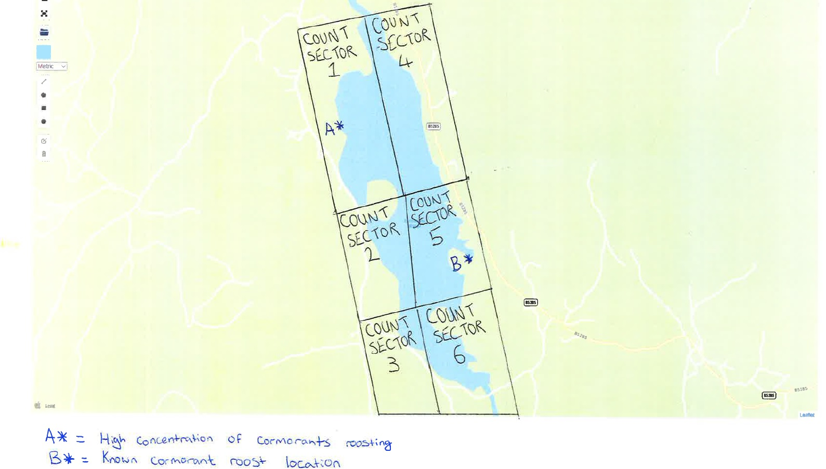
Example 2 – Large Stillwater (over 20Ha)

